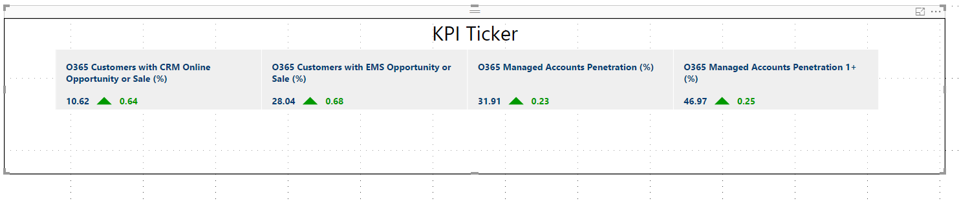

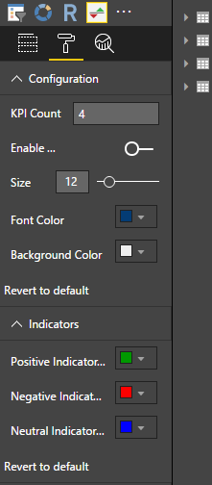 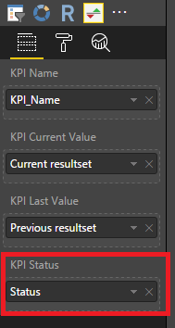

KPI Status:

* The column selected for KPI Status must have values -1,0 or 1.
* -1 for negative change, 0 for no change and 1 for positive change.

Configuration:

1. KPI Count: Specify number of KPI visible at a time. Minimum number is 1 and maximum is 4
2. Enable Delta: Specify if percentage change is to be shown or not.
3. Size: Specify text size
4. Font Color: Specify text color
5. Background Color: Specify the background color of the ticker

Indicators:

1. Positive Indicator Color: Specify the color for positive indicator
2. Negative Indicator Color: Specify the color for negative indicator
3. Neutral Indicator Color: Specify the color for neutral indicator